]

We are getting married!

Click to save the date

**Save the Date, October 12th**

**Google Address   
Marriage**

**CSI JCM Church, Madanapalle.**

**Reception**

**NVR Convention Hall,**

**Near H.P Gas office,**

**Buggakaluva, Madanapalle**

**Timer Days left clock**



Swapna

&

Anurag

Invite you to celebrate our wedding

10 am on 12th of October, 2018

Madanapalle, Andhra Pradesh

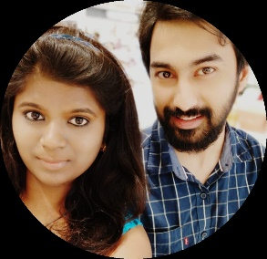

**October 11th, 5 P.M**

**Betrothal ceremony**

**Please fill the form here**

**Laughter**

**Photography**

**Food**

**October 12th, 10:30 A.M**

**Wedding**

**October 12th, 12:30 P.M**

**Reception**

**Photography**